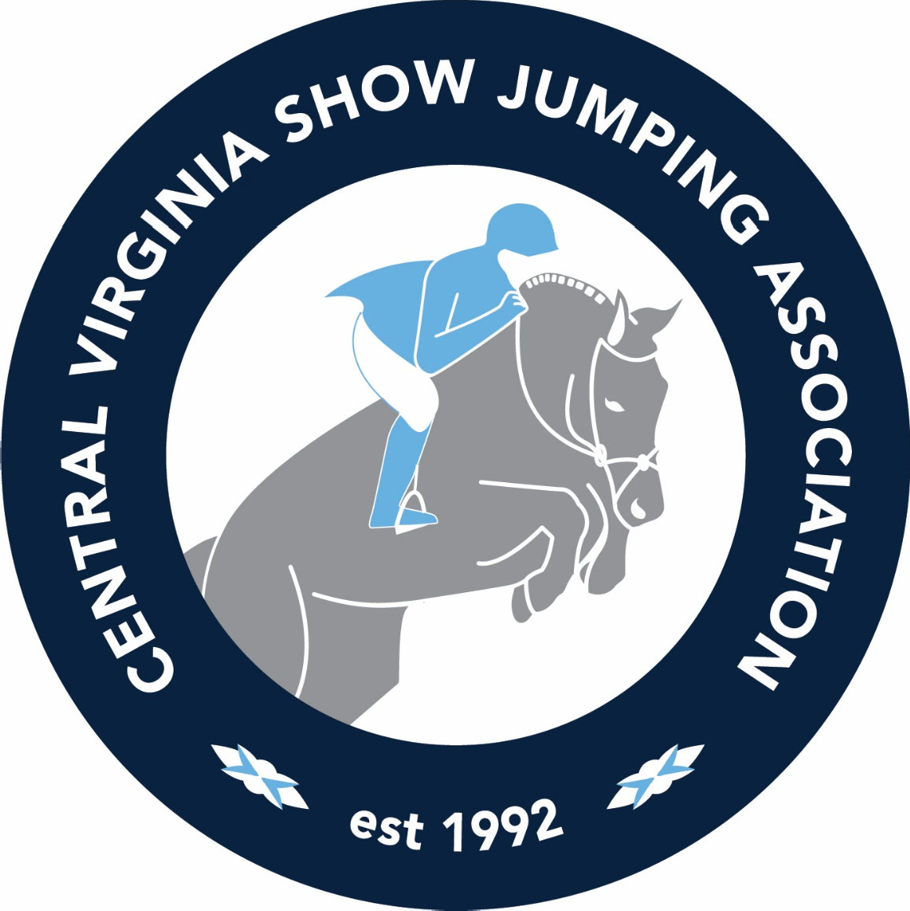

MEDIA KIT

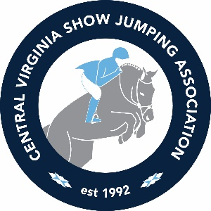
2023 MEDIA KIT
Adverting and Sponsorship Opportunities

Central Virginia Show Jumping Association, Inc. is a non-profit sports/educational organization. We are dedicated to the sport of show jumping with a major emphasis on horsemanship, sportsmanship, and safety. Our goal is to make our shows the most fun and desired horse show events to attend in the Central VA area.

We will run 10 horse shows (weather permitting) at the Deep Run Show Grounds and plan to host 1 or 2 training clinics with an emphasis on horsemanship, equitation and of course, jumping.

The success of our cross rails class last year has persuaded us to expand this class to its own division in 2023. We have come to recognize our youngest members enthusiasm for show jumping and are thrilled to provide them more involvement. The division will consist of 2 optimum time classes.

This past year we introduced a new member portal so members have one place to keep track of all their exhibitor information, show entries, points and provide an easy platform for registering for membership and entering our shows. We will continue to refine the portal to make it even easier to use in 2023.

Our commitment to young riders and education is emphasized by our Annual $5,000 Rebecca Lipscombe and $1,000 Alia Fagerburg Memorial Scholarships awarded to the most deserving young members.

We have roughly 300 plus members and close to 400 horses register each year. Approximately 100 individual riders compete at each of our shows and bring plenty of friends and family with them.

In the past year, we have increased our social media presence. Our Facebook page currently has 1,432 follows and on average 800 people see each post. On Instagram, we currently have 572 followers and our posts reach 300 followers and non-followers on average.

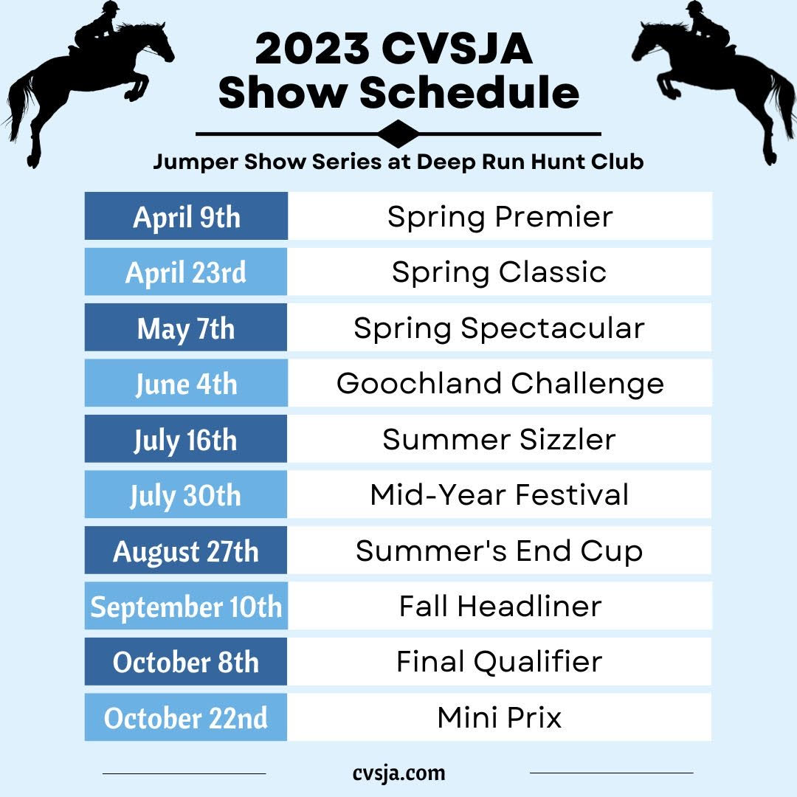

We hope you will consider the following options and choose to support CVSJA this year.

Sincerely,

Kimberly Anderson and Sulu Rose Reed
Co-Presidents
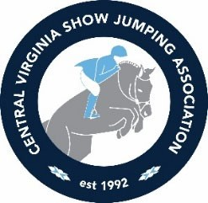

CVSJA MARKETING OPPORTUNITIES

SPONSORSHIPS

Marquis Sponsor (Your Name - Presents CVJSA Show Jumping Association) |  | $5,000 |  |  | O | Name on Cover of Prize List, Headliner on Website, all poster and show print advertising, social media promotion
 |  |  |  |  | O | Premium Color 2 Page Center Spread Ad in Prize List
 |  |  |  |  | O | Ring and Show Ground signage and Announcements at Shows
 |  |  |  |  |  | Jump Designed with your Name and Image
Year End Dinner |  | $2,000 |  |  | O | Full Page Color Ad in Prize List
 |  |  |  |  | O | Website, Announcements, Year End Dinner Flyers/Mailings, social media promotion
YE Cocktail Reception |  | $1,000 |  |  | O | Half Page Color Ad in Prize List
 |  |  |  |  | O | Website, Announcements, Year End Dinner Flyers/Mailings, social media promotion
Jump Sponsor |  | $800 | 375 (renew) |  | O | Your Brand and Colors, You suggest jump design with our standard sizes
 |  |  |  |  | O | Mentioned in Prize List, Show Announcements and on website, social media promotion
Water Bottles |  | $1,000 |  |  | O | Name on label, staged at ingates of both rings at all shows.
 |  |  |  |  | O | Mentioned in Prize List, Show Announcements and on website, social media promotion
Winner Circle Sponsor |  | $500 |  |  | O | Signage at Winner's Circle
 |  |  |  |  | O | Mention in Prize List, Show Announcements and on website, social media promotion
Division for the Year |  | $500 |  |  | O | 1/2 P BW Ad Included
 |  |  |  |  | O | Mention in Prize List, Show Announcements and on website, social media promotion
Ice Cream Social or Special Hospitality |  | $400 |  |  | O | Mentioned in Prize List, Show Announcements and on website, social media promotion

PRIZE LIST ADVERTISING
You don't just get a print ad, see below for all the extra perks.

All Color full page advertisers:
Will be featured on our website, mentioned on event posters, in addition to the following
All Color full and half page advertisers:
Will be promoted through announcements at all the horse shows. May display marketing materials in our Sponsors Tent at each show.
All B/W full page advertisers
Will be promoted through announcements at the horse shows.
May display marketing materials in our Sponsors Tent at each show.

Website traffic currently over 400 views per month. (Exhibitors use the website to register for horse shows) We use Facebook and Instagram too.
Printed books are, mailed to full membership, displayed at local businesses and at horse shows. Books are used on average 8 times per year, over 5,000 impressions.

Premium Pages

Full Color‐Full Page | Inside Front Cover | $ 450
(5" x 7.5") | Inside Back Cover | $ 450
 | Facing Inside Back Cover | $ 400
 | Facing Table of Contents | $ 400
 | Centerfold L or R | $ 400
Standard Pages

Color Ads | Full Page | (5" x 7.5") | $ 375
 | 1/2 Page | (5" x 3.75") | $ 275
 | 1/4 Page | (2.5" x 3.75") | $ 150
B/W Ads | Full Page | (5" x 7.5") | $ 325
 | 1/2 Page | (5" x 3.75") | $ 250
 | 1/4 Page | (2.5" x 3.75") | $ 125

VENDOR SPACES AT SHOW AND EVENTS

Vendor Space w/Tent and Table | Full Year | $400
 | Per Event | $50
Vendor Space w/o Tent and Table | Full Year | $300
 | Per Event | $40

½ Page Color
$275
5” x 3 ½”
½ Page BW
$250
¼ Page Color
$150
¼ Page BW
$125
2” x 3 ½”
2” x 3 ½”

FULL PAGE
COLOR
$375

5” x 7 ½”

OR

FULL PAGE
B/W
$325

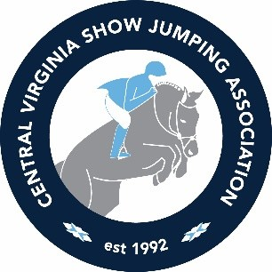
2023 CVSJA Marketing Agreement

All information in grey boxes required

Name Company Address City, ST ZIP Phone Email

Advertising Options Sponsorship Options
Premium Pages
Full Color - Full Page | Inside Front Cover | $450
 | Inside Back Cover | $450
 | Facing Inside Back Cover | $400
 | Facing Table of Contents | $400
 | Facing Show Schedule | $400
 | Centerfold L or R | $400
Standard Pages
Color Ads | Full Page (5" x 7.5") | $375
 | 1/2 Page (5 x 3.75") | $275
 | 1/4 Page (2.5" x 3.75") | $150
Black and White | Full Page (5" x 7.5") | $325
 | 1/2 Page (5 x 3.75") | $250
 | 1/4 Page (2.5" x 3.75") | $125

Marquis Sponsor | $5,000
Year End Dinner | $3,000
Year End Cocktail Party | $1,500
Water Bottle Private Label | $1,000
Jump Sponsor New | $800
Renew | $375
Division Sponsor for Year | $500
Winner Circle Sponsor | $500
Ice Cream Social or Special Hospitality | $400

Vendor Space w/Tent and Table | Full Year $400 | Per Event $50
Vendor Space w/o Tent and Table | Full Year $300 | Per Event $40

PLEASE WRITE YOUR SELECTIONS IN BLANKS BELOW (You will not be billed until 2023)
$
$
$
Signature Total
$
Payment Options Bill Me or Credit Card #
Exp. CVV

Please provide Company Information for our announcers below.
What would you like our announcers to say about your company at our shows.

Please provide your website and social media tags, if applicable:

Or you may email the above information to CVSJAshows@gmail.com

Please return contracts to:
CVSJA Fund Raising, 1541 Manakin Road, Manakin Sabot, VA 23103 or you may email to the above email address.

